# B. K. BIRLA COLLEGE OF ARTS, SCIENCE & COMMERCE (AUTONOMOUS), KALYAN

**PROJECT REPORT ON**

**STUDY OF EFFECT OF HEAVY METALS ON CERTAIN COMPONENT PRESENT IN SHOOTS OF VETIVER GRASS**

**(*Vetiveria Zizanioides*)**

# SUBMITTED BY PRITI MOHAN KUMBHAR

**DEPARTMENT OF ENVIRONMENTAL SCIENCES PART –II (SEMESTER IV)**

**UNDER GUIDANCE OF DR.SONAL TAWDE INCHARGE**

**DEPARTMENT OF ENVIRONMENTAL SCIENCES B.K.BIRLA COLLEGE (AUTONOMOUS), KALYAN**

**B. K. BIRLA COLLEGE OF ARTS, SCIENCE & COMMERCE (AUTONOMOUS), KALYAN**



**CERTIFICATE**

Exam Seat No.

This is to certify that the project work entitles “**Study of Effects of Heavy Metals in Certain Components Present in Shoots of Vetiver Grass”** has been carried out by **Ms. Priti Mohan Kumbhar** of M.Sc. Part II, (Semester V) Environmental Sciences, B.K. Birla College of Arts, Science & Commerce (Autonomous),

Kalyan of the fulfilment of degree of masters of sciences in Environmental Sciences during the Academic year 2019-2020.

Date:

Dr. (Mrs.) Sonal Tawde In-charge,

Dept. of Environmental Sciences Examiners:

# ACKNOWLEDGEMENT

The success and final output of this project required a lot of guidance and assistance from many people and I am privileged to have got this all along the completion of my project. All that I have done is only due to such supervision and assistance and would not forget to thank them.

I express my sincere thanks my guide **DR. (Mrs.) SONAL TAWDE** for guiding me in completion of the project, for her consult, help, motivation, and invaluable guidance, constructive and practical guidance throughout the course of study. I gratefully thank her for always being the source of inspiration and always guiding me to get through queries and doubts that came in the way.

I am thankful to our principal **Dr. (Mr.) Avinash Patil** , and to the management of Birla college for kind provision of all the facilities, for immense support and never –ending zeal during the entire academics and the course of project.

I am very thankful to **Dr. (Mrs.) Vandana Gupta,** assistant professor for helping and supporting me in my doubts and ifficulties throughout the project.

I am also thankful to Lab Assistance sir for providing all the required media, glassware, instruments, for project work. I acknowledge the cooperation of all non- teaching staff members of department of environmental sciences, Birla College, Kalyan.

I would also like to express my thanks to my friend’s siddhi, for their support and encouragement throughout project.

Finally, I must express my profound gratitude to my parents, Mr.Mohan K. Kumbhar and Mrs. Suvarna K.Kumbhar for providing me with unfailing support and continuous encouragement throughout the project. This accomplishment would not have been possible without them.

Thank you!

**Priti Mohan Kumbhar**

**INDEX**

|  |  |  |
| --- | --- | --- |
| **CHAPTER** | **CONTENT** | **PAGE NO.** |
|  | **ACKNOWLEDGEMENT** |  |
| **1.** | **INTRODUCTION** | **5** |
| **2.** | **REVIEW OF LITERATURE** | **11** |
| **3.** | **AIM AND OBJECTIVE** | **20** |
| **4.** | **MATERIALS AND METHODOLOGY** | **21** |
| **5.** | **OBSERVATION** | **26** |
| **6.** | **RESULT AND DISCUSSION** | **28** |
| **7.** | **CONCLUSION** | **29** |
| **8.** | **REFERENCE** | **30** |

**CHAPTER I INTRODUCTION**

* 1. **VETIVER PLANT:**

Soil is an integral part of the environment that is involved in many ecosystem services. However, decline in the actual and/or potential productivity of soils due to poor land management practices has become a major challenge to sustainable agriculture and environmental quality thus threatening the food security of many countries of the world. According to Truong some of these poor land management practices often lead to soil erosion and agro-chemical contamination from agricultural practices, urban wastes and industrial operations, which adversely reduces soil’s potential for sustainable food production, consequently affecting plants, animals and human lives.

**Chrysopogon zizanioides**, commonly known as **vetiver** is a per[ennial bunchgrass](https://en.wikipedia.org/wiki/Bunchgrass) of the [family](https://en.wikipedia.org/wiki/Family_(biology)) [Poaceae,](https://en.wikipedia.org/wiki/Poaceae) native to India.Vetiver is most closely related to [Sorghum](https://en.wikipedia.org/wiki/Sorghum) but shares many morphological characteristics with other fragrant grasses, such as [lemongrass](https://en.wikipedia.org/wiki/Cymbopogon) [(Cymbopogon citratus),](https://en.wikipedia.org/wiki/Cymbopogon_citratus) [citronella](https://en.wikipedia.org/wiki/Citronella_oil) [(Cymbopogon nardus,](https://en.wikipedia.org/wiki/Cymbopogon_nardus) C. winterianus), and palmarosa [(Cymbopogon martinii)](https://en.wikipedia.org/wiki/Cymbopogon_martinii).Vetiver grows to 150 centimeters high and form clumps as wide. Under favorable conditions, the erect culms can reach 3m in height. The stems are tall and the leaves are long, thin, and rather rigid. The flowers are brownish-purple. Unlike most grasses, which form horizontally spreading, mat-like root systems, vetiver's roots grow downward, 2 meters to 4 meters (13 ft.) in depth. The vetiver [bunch](https://en.wikipedia.org/wiki/Bunch_grass) [grass](https://en.wikipedia.org/wiki/Bunch_grass) has a [gregarious](https://en.wikipedia.org/wiki/Gregarious) habit and grows in tufts. [Shoots](https://en.wikipedia.org/wiki/Shoots) growing from the underground crown make the plant [frost](https://en.wikipedia.org/wiki/Frost) and [wildfire](https://en.wikipedia.org/wiki/Wildfire) resistant, and allow it to survive heavy [grazing](https://en.wikipedia.org/wiki/Grazing) pressure. The [leaves](https://en.wikipedia.org/wiki/Leaves) can become up to 300 centimeters (10 ft.) long and 8 millimeters (0.3 in) wide. The [panicles](https://en.wikipedia.org/wiki/Panicles) are 15 centimeters (6 in) to 30 centimeters (12 in) long and have whorled, 25 millimeters (1 in) to 50 millimeters (2 in) long [branches.](https://en.wikipedia.org/wiki/Branches) The [spikelet’s](https://en.wikipedia.org/wiki/Spikelets) are in pairs, and there are three stamens. The [plant stems](https://en.wikipedia.org/wiki/Plant_stems) are erect and stiff. They can survive deep water flow. Under clear water, the plant can survive up to two months. The [root system](https://en.wikipedia.org/wiki/Root) of vetiver is finely structured and very strong. It can grow 3 meters (10 ft.) to 4 meters (13 ft.) deep within the first year. Vetiver has neither stolons nor [rhizomes.](https://en.wikipedia.org/wiki/Rhizome) Because of all these characteristics, the vetiver plant is highly [drought-tolerant](https://en.wikipedia.org/wiki/Drought_tolerance) and can help to protect soil against [sheet erosion.](https://en.wikipedia.org/wiki/Sheet_erosion) In case of [sediment deposition,](https://en.wikipedia.org/wiki/Sediment_deposition) new roots can grow out of buried [nodes.](https://en.wikipedia.org/wiki/Plant_stem)

**Vetiver**,(Chrysopogon zizanioides),also called **khus-khus**, [perennial](https://www.britannica.com/science/perennial) [grass](https://www.britannica.com/plant/grass) of the family [Poaceae,](https://www.britannica.com/plant/Poaceae) the roots of which contain an [oil](https://www.britannica.com/topic/essential-oil) used in perfumes. Vetiver is native to tropical Asia and has been introduced into the tropics of both hemispheres; it has escaped cultivation and become a [weed](https://www.britannica.com/plant/weed) in some regions.

* 1. **HEAVY METAL:**

Heavy metals are generally defined as [metals](https://en.wikipedia.org/wiki/Metal) with relatively high [densities,](https://en.wikipedia.org/wiki/Density) [atomic weights,](https://en.wikipedia.org/wiki/Atomic_weight) or [atomic numbers.](https://en.wikipedia.org/wiki/Atomic_number) Some heavy metals are either essential nutrients (typically iron, [cobalt,](https://en.wikipedia.org/wiki/Cobalt) and [zinc),](https://en.wikipedia.org/wiki/Zinc) or relatively harmless (such as [ruthenium,](https://en.wikipedia.org/wiki/Ruthenium) silver, and [indium),](https://en.wikipedia.org/wiki/Indium) but can be toxic in larger amounts or certain forms. Other heavy metals, such as [cadmium,](https://en.wikipedia.org/wiki/Cadmium) mercury, and lead, are highly poisonous. Potential sources of heavy metal poisoning include [mining,](https://en.wikipedia.org/wiki/Mining) [tailings,](https://en.wikipedia.org/wiki/Tailings) [industrial Physical and chemical characterisations of heavy metals need to be treated with caution, as](https://en.wikipedia.org/wiki/Industrial_waste) [the metals involved are not always consistently defined. As well as being relatively dense, heavy metals tend to](https://en.wikipedia.org/wiki/Industrial_waste) [be less reactive than lighter metals and have far fewer soluble sulfides and hydroxides.](https://en.wikipedia.org/wiki/Industrial_waste) [While it is relatively](https://en.wikipedia.org/wiki/Industrial_waste) [easy to distinguish a heavy metal such as tungsten from a lighter metal such as](https://en.wikipedia.org/wiki/Industrial_waste) [sodium,](https://en.wikipedia.org/wiki/Sodium) [a few heavy metals,](https://en.wikipedia.org/wiki/Industrial_waste) [such as zinc, mercury, and lead, have some of the characteristics of lighter metals, and, lighter metals such as](https://en.wikipedia.org/wiki/Industrial_waste) [beryllium,](https://en.wikipedia.org/wiki/Beryllium) [scandium,](https://en.wikipedia.org/wiki/Scandium) [and titanium, have some of the characteristics of heavier metals.](https://en.wikipedia.org/wiki/Industrial_waste) [Heavy metals are](https://en.wikipedia.org/wiki/Industrial_waste) [relatively scarce in the Earth's crust but are present in many aspects of modern life. They are](https://en.wikipedia.org/wiki/Industrial_waste) [used in, for](https://en.wikipedia.org/wiki/Industrial_waste) [example,](https://en.wikipedia.org/wiki/Industrial_waste) [golf clubs,](https://en.wikipedia.org/wiki/Golf_club) [cars,](https://en.wikipedia.org/wiki/Cars) [antiseptics,](https://en.wikipedia.org/wiki/Antiseptic) [self-cleaning ovens,](https://en.wikipedia.org/wiki/Self-cleaning_oven) [plastics,](https://en.wikipedia.org/wiki/Plastic) [solar panels,](https://en.wikipedia.org/wiki/Solar_panel) [mobile phones,](https://en.wikipedia.org/wiki/Mobile_phone) [and particle](https://en.wikipedia.org/wiki/Industrial_waste) [accelerators.wastes,](https://en.wikipedia.org/wiki/Industrial_waste) [agricultural runoff,](https://en.wikipedia.org/wiki/Agricultural_runoff) [occupational exposure,](https://en.wikipedia.org/wiki/Chemical_hazard) [paints](https://en.wikipedia.org/wiki/Environmental_impact_of_paint) and treated timber.

Physical and chemical characterizations of heavy metals need to be treated with caution, as the metals involved are not always consistently defined. As well as being relatively dense, heavy metals tend to be less [reactive](https://en.wikipedia.org/wiki/Chemical_reaction) than lighter metals and have far fewer [soluble](https://en.wikipedia.org/wiki/Solubility) [sulfides](https://en.wikipedia.org/wiki/Sulfide) and [hydroxides.](https://en.wikipedia.org/wiki/Hydroxide) While it is relatively easy to distinguish a heavy metal such as [tungsten](https://en.wikipedia.org/wiki/Tungsten) from a lighter metal such as [sodium,](https://en.wikipedia.org/wiki/Sodium) a few heavy metals, such as zinc, mercury, and lead, have some of the characteristics of lighter metals, and, lighter metals such as [beryllium,](https://en.wikipedia.org/wiki/Beryllium) [scandium,](https://en.wikipedia.org/wiki/Scandium) and titanium, have some of the characteristics of heavier metals.

Heavy metals are relatively scarce in the [Earth's crust](https://en.wikipedia.org/wiki/Structure_of_the_Earth#Crust) but are present in many aspects of modern life. They are used in, for example, [golf clubs,](https://en.wikipedia.org/wiki/Golf_club) [cars,](https://en.wikipedia.org/wiki/Cars) [antiseptics,](https://en.wikipedia.org/wiki/Antiseptic) [self-cleaning ovens,](https://en.wikipedia.org/wiki/Self-cleaning_oven) [plastics,](https://en.wikipedia.org/wiki/Plastic) [solar panels,](https://en.wikipedia.org/wiki/Solar_panel) [mobile phones,](https://en.wikipedia.org/wiki/Mobile_phone) and [particle accelerators.](https://en.wikipedia.org/wiki/Particle_accelerator)

Heavy metals are naturally occurring elements that have a high atomic weight and a density at least 5 times greater than that of water. Their multiple industrial, domestic, agricultural, medical and technological applications have led to their wide distribution in the environment; raising concerns over their potential effects on human health and the environment. Their toxicity depends on several factors including the dose, route of exposure, and chemical species, as well as the age, gender, genetics, and nutritional status of exposed individuals. Because of their high degree of toxicity, arsenic, cadmium, chromium, lead, and mercury rank among the priority metals that are of public health significance. These metallic elements are considered

6

systemic toxicants that are known to induce multiple organ damage, even at lower levels of exposure. They are also classified as human carcinogens (known or probable) according to the U.S. Environmental Protection Agency, and the International Agency for Research on Cancer. This review provides an analysis of their environmental occurrence, production and use, potential for human exposure, and molecular mechanisms of toxicity, genotoxicity, and carcinogenicity.

In biological systems, heavy metals have been reported to affect cellular organelles and components such as cell membrane, mitochondrial, lysosome, endoplasmic reticulum, nuclei, and some enzymes involved in metabolism, detoxification, and damage repair Metal ions have been found to interact with cell components such as DNA and nuclear proteins, causing DNA damage and conformational changes that may lead to cell cycle modulation, carcinogenesis or apoptosis. Several studies from our laboratory have demonstrated that reactive oxygen species (ROS) production and oxidative stress play a key role in the toxicity and carcinogenicity of metals such as arsenic, cadmium, chromium lead and mercury. Because of their high degree of toxicity, these five elements rank among the priority metals that are of great public health significance. They are all systemic toxicants that are known to induce multiple organ damage, even at lower levels of exposure. According to the United States Environmental Protection Agency (U.S. EPA), and the International Agency for Research on Cancer (IARC), these metals are also classified as either “known” or “probable” human carcinogens based on epidemiological and experimental studies showing an association between exposure and cancer incidence in humans and animals.

Heavy metal-induced toxicity and carcinogenicity involves many mechanistic aspects, some of which are not clearly elucidated or understood. However, each metal is known to have unique features and physic-chemical properties that confer to its specific toxicological mechanisms of action. This review provides an analysis of the environmental occurrence, production and use, potential for human exposure, and molecular mechanisms of toxicity, genotoxicity, and carcinogenicity of arsenic, cadmium, chromium, lead, and mercury.

## USES

Vetiver grass is grown for many purposes. The plant helps to stabilise [soil](https://en.wikipedia.org/wiki/Soil) and protects it against [erosion,](https://en.wikipedia.org/wiki/Erosion) but it can also protect [fields](https://en.wikipedia.org/wiki/Field_(agriculture)) against pests and [weeds.](https://en.wikipedia.org/wiki/Weed) Vetiver has favorable qualities for [animal feed.](https://en.wikipedia.org/wiki/Fodder) From the roots, [oil](https://en.wikipedia.org/wiki/Oil) is extracted and used for [cosmetics,](https://en.wikipedia.org/wiki/Cosmetics) [aromatherapy,](https://en.wikipedia.org/wiki/Aromatherapy) herbal skincare and [ayurvedic](https://en.wikipedia.org/wiki/The_Ayurvedic_Institute) soap. Due to its [fibrous](https://en.wikipedia.org/wiki/Fibrous) properties, the plant can also be used for [handicrafts,](https://en.wikipedia.org/wiki/Handicraft) [ropes](https://en.wikipedia.org/wiki/Rope) and more.

## SKIN CARE

Vetiver has been used to produce perfumes, creams and soaps. It is used for its antiseptic properties to treat acne and sores.

### Crop protection and pest repellent

Vetiver can be used for crop protection. It attracts the stem borer [(Chilo partellus),](https://en.wikipedia.org/wiki/Chilo_partellus) which lay their eggs preferentially on vetiver. Due to the hairy architecture of vetiver, the larvae cannot move on the leaves, fall to the ground and die. Vetiver's [essential oil](https://en.wikipedia.org/wiki/Essential_oil) has anti-fungal properties against Rhizoctonia solani. As a mulch, vetiver is used for weed [control](https://en.wikipedia.org/wiki/Weed_control) in [coffee,](https://en.wikipedia.org/wiki/Coffee) [cocoa](https://en.wikipedia.org/wiki/Theobroma_cacao) and [tea](https://en.wikipedia.org/wiki/Tea) plantations. It builds a barrier in the form of a thick mat.Whenthe mulch breaks down, [soil organic matter](https://en.wikipedia.org/wiki/Soil_organic_matter) is built up and additional crop [nutrients](https://en.wikipedia.org/wiki/Nutrients) become available.



## MEDICINE

Vetiver has been used in traditional medicine in South Asia (India, Pakistan, Sri Lanka), Southeast Asia (Malaysia, Indonesia, Thailand), and West Africa. Old Tamil literature mentions the use of vetiver for medical purposes.



## OTHER USES

Vetiver grass is used as [roof thatch](https://en.wikipedia.org/wiki/Thatch) (it lasts longer than other materials) and in [mud brick](https://en.wikipedia.org/wiki/Mud_brick)-making for housing construction (such bricks have lower thermal conductivity). It is also made into [strings](https://en.wikipedia.org/wiki/Twine) and [ropes,](https://en.wikipedia.org/wiki/Rope) and grown as an [ornamental plant](https://en.wikipedia.org/wiki/Ornamental_plant) (for the light [purple](https://en.wikipedia.org/wiki/Purple) [flowers)](https://en.wikipedia.org/wiki/Flowers)[.[3]](https://en.wikipedia.org/wiki/Chrysopogon_zizanioides#cite_note-Technical_Manual-3)

Garlands made of vetiver grass are used to adorn the [murti](https://en.wikipedia.org/wiki/Murti) of [Lord Nataraja](https://en.wikipedia.org/wiki/Nataraja) (Shiva) in Hindu temples. It is a favorite offering to [Ganesha.](https://en.wikipedia.org/wiki/Ganesha)

Vetiver oil has been used in an effort to track where mosquitoes live during dry seasons in Sub-Saharan Africa. Mosquitoes were tagged with strings soaked in vetiver oil then released. Dogs trained to track the scent, not native to Africa, found the marked mosquitoes in such places as holes in trees and in old termite mounds.

## CHARACTERISTICS OF VETIVER PLANT:

* + 1. **MORPHOLOGICAL CHARACTERISTICS:**
       - Vetiver grass does not have stolons or rhizomes. Its massive finely structured root system can grow very fast, in some applications rooting depth can reach 3-4m in the first year. This deep root system makes vetiver plant extremely drought tolerant and difficult to dislodge by strong water currents.
       - Stiff and erect stems that can stand up to relatively deep water flows - Photo 1.
       - Highly resistance to pests, diseases and fire - Photo 2.
       - A dense hedge is formed when planted close together acting as a very effective sediment filter and water spreader.
       - New shoots develop from the underground crown making vetiver resistant to fire, frosts, traffic and heavy grazing pressure.
       - New roots grow from nodes when buried by trapped sediment. Vetiver will continue to grow up with the deposited silt eventually forming terraces, if trapped sediment is not removed.

## PHYSIOLOGICAL CHARACTERISTICS

* + - * Tolerance to extreme climatic variation such as prolonged drought, flood, submergence and extreme temperature from -14ºC to +55ºC.
      * Ability to re-grow very quickly after being affected by drought, frosts, salinity and adverse conditions after the weather improves or soil ameliorants added.
      * Tolerance to wide range of soil pH from 3.3 to 12.5 without soil amendment.
      * High level of tolerance to herbicides and pesticides.
      * Highly efficient in absorbing dissolved nutrients such as N and P and heavy metals in polluted water.
      * Highly tolerant to growing medium high in acidity, alkalinity, salinity, sodicity and magnesium.
      * Highly tolerant to Al, Mn and heavy metals such as As, Cd, Cr, Ni, Pb, Hg, Se and Zn in the soils.

## ECOLOGICAL CHARACTERISTICS

* + - * Vetiver is very tolerant to some extreme soil and climatic conditions mentioned above, as typical tropical grass, it is intolerant to shading.
      * Shading will reduce its growth and in extreme cases, may even eliminate vetiver in the long term.
      * Vetiver grows best in an open and weed free environment, weed control may be needed during establishment phase.
      * On erodible or unstable ground vetiver first reduces erosion, stabilizes the erodible ground (particularly steep slopes), then because of nutrient and moisture conservation, improves its micro-environment so other volunteered or sown plants can establish later. Because of these characteristics vetiver can be considered as a nurse plant on disturbe[d lands.(https://www.vetiver.org/TVN- Handbook%20series/TVN-se vetiver%20plant.htm)](https://www.vetiver.org/TVN-Handbook%20series/TVN-se%20vetiver%20plant.htm)

## APPLICATION OF VETIVER PLANT:

The application of vetiver grass as a technology for soil and water conservation was first developed in India by the World Bank in the 1980s. Some of the applications of vetiver grass technology, which could sum up to the enhancement of sustainable agricultural development, include its use for soil erosion and sediment control on sloping farmlands and floodplains rehabilitation of saline and acid sulphate soils bioremediation of agro- chemicals; biological pest control ; and on- and off-site heavy metal pollution control amongst others.

## EROSION AND SEDIMENT CONTROL

Erosion, which is simply the washing away of soils by ‘agents’ such as water and wind, is a phenomenon that has ravaged so many lands, resulting in soil degradation and consequently low crop yield. According to National Research Council, it is among the most devastating environmental disaster for many developing countries and it results in loss of huge amounts of valuable soils which are key to agricultural production.

## REHABILITATION OF SALINE AND ACID SULPHATE SOILS

Salinity, which is the amount of dissolved salt content of a soil or water body, is a major challenge confronting agricultural production especially in semi-arid regions of the world with respect to crop. According to Truong and Baker vetiver grass that could cope with saline soils has been successfully employed in the rehabilitation of salt-affected lands. This may be due to its high tolerance to salt-affected soils.

## BIOREMEDIATION OF AGRO-CHEMICALS

Agro-chemicals (pesticides, herbicides, and even fertilizers) have been reported to adversely affect soil properties and water quality. This adverse effect is finally expressed in the quality of crop produced. According to Truong,vetiver has played an important role in the decontamination of agro-chemicals due to its ability to retain them within its system, thereby preventing them from contaminating and accumulating in soils and crops. [Table 3](https://www.intechopen.com/books/grasses-benefits-diversities-and-functional-roles/vetiver-grass-a-tool-for-sustainable-agriculture#tab3) shows the threshold levels of heavy metals to vetiver grass.

## BIOLOGICAL PEST CONTROL

Insects and pests are two of the most destructive biological pests known to cause damage to agricultural crops and consequently leading to reduction in crop yield. The use of agro-chemicals in controlling most of these pests results in adverse effects on both soils and crops. Results of the research carried out in Guangxi University, China, after subjecting vetiver grass to insect attack, showed that of the 79 species of insect found on vetiver rows, only four attacked young vetiver leaves. He explained that due to few insects that could attack vetiver grass, the damage was minimal. (htt[ps://www.int](http://www.intechopen.com/books/grasses))e[chopen.com/books/grasses)](http://www.intechopen.com/books/grasses))

# CHAPTER 2 REVIEW OF LITERATURE

## APPLICATIONS OF VETIVER GRASS (CHRYSOPOGON ZIZANIOIDES) IN ECO SYSTEM

Joice K Joseph, Amrutha Haridasan, Karunakaran Akhildev and Pradeep Kumar

J. Geogr Nat Disast (2017) p.g 652-657.

## ABSTRACT

The correlation between ecosystem and disasters are widely documented but inadequately integrated in to disaster risk reduction initiatives and developmental programs. The present work examines the scope of vetiver system as a natural solution for various environmental risk reduction activities. The Vetiver System (VS), which is based on the application of vetiver grass - a perennial grass of Indian origin (Vetiveria zizanioides L Nash, now reclassified as Chrysopogon zizanioides L Roberty), was first developed by the World Bank for soil and water conservation in the mid-1980s. It is a very simple, practical, inexpensive, low maintenance and incredibly efficient means of natural disaster reduction. The two case works in the study reported here documents the success of VS application in the state of Kerala in India and the implementation strategy for the vetiver system in the fields with the collaboration of Mahatma Gandhi National Rural Employment Guarantee Act (MGNREGA). The study also identifies the potential entry points of VS in the ecosystem based disaster risk reduction (Eco-DRR). Integrating local level disaster risk reduction activities in the national level programs will ensure the sectoral integration in DRR initiatives. Vetiver system can very effectively be used as a cost EFFECTIVE and efficient Eco DRR technology that can address both long term and short term risk with ecosystem management.

Keywords: Vetiver system; Eco-DRR; Case studies; MGNREGA

## TRADITIONAL AND MEDICINAL USES OF VETIVER

D. Balasankar, K. Vanilarasu, P. Selva Preetha, S.Rajeswari M.Umadevi, Debjit Bhowmik Traditional & medicinal use of vetiver (2013).

## ABSTRACT

In the India the vetiver plant is known as the “Khus” or “Khus-khus” and is used both in medicine and in the industry of perfumery, of frozen foods and refrigeration in the preparation of all kinds of drinks. The grass is characterized by a sweet and pleasant flavor combined with a little earthy. On the other hand is a very fresh herb has a cooling effect similar to some other herbs such as mint or peppermint. Vetiver is a tall, tufted, perennial, scented grass with a straight stem, long narrow leaves and a lacework root system that is abundant, complex and extensive. It has versatile uses, particularly as an inexpensive yet effective and eco-friendly tool to combat soil erosion. Medicinal and aromatic plants (MAP) are two related groups of plants having in their part chemical constituents which are active in curing ailments (i.e. MP) or in providing flavors and/or fragrances (i.e. AP). Harvested vetiver leaves, culms and roots are utilized after some degree of processing in various ways, e.g. as input of agriculture related activities (mulch, compost, nursery block / planting medium, animal feed stuff, mushroom cultivation, botanical pesticides, and allelopathy), handicraft and art works, medicinal applications, fragrance, input of construction related activities (roof thatch, hut, mud brick, vetiver-clay composite storage bin, veneer / fiber board, artificial pozzalans, ash for concrete work, and straw bale), containers (pottery, melamine utensils, water containers), bouquet, energy sources (ethanol, green fuel), industrial products (pulp and paper, panel), and miscellaneous other utilization.

Keyword: Vetiver, Allelopathy, Medicinal use, Essential oil, Aromatherapy.

## UPTAKE POTENTIAL OF SOME HEAVY METALS BY VETIVER GRASS

Nualchavee Roongtanakiat, Prapai Chairoj

Agricultural & Natural Resources (2016) 35 (1), 46-50, 2001

## ABSTRACT:

The uptake potential of upland vetiver grass (Vetiveria nemoralis) ecotype Kamphaeng Phet and lowland vetiver grass (Vetiveria zizanioides) ecotypes Ratchaburi and Surat Thani, for different heavy metals was evaluated. Varying amounts of manganese (Mn), zinc (Zn), copper (Cu) cadmium (Cd) and lead (Pb) were applied to one-month old vetiver grass planted in pots. Vetiver grass plants were harvested at 60 and 120 days after the heavy metal application and the concentrations of the heavy metals in shoot and root parts were determined using atomic absorption spectrophotometry. The results indicated that at the concentrations tested, the heavy metals applied had no significant effect on growth of all vetiver grass ecotypes. Vetiver grass harvested at 120 days yielded more shoot dry matter than those harvested at 60 days. The Ratchaburi ecotype demonstrated significantly increased in root mass at the 120-day harvest. No obvious increase for Kamphaeng Phet and Surat Thani and no significant difference in root between these ecotypes mass were observed. For the three vetiver grass ecotypes tested, the uptake of heavy metals was proportional to the concentration of the applied heavy metals. The Ratchaburi ecotype had the highest concentration of the heavy metals in shoots, except at the 120-day harvest, Pb concentration was significantly lower than that of the Kamphaeng Phet ecotype. The concentration of heavy metals in vetiver grass shoots harvested at 120 days was lower than that of the 60-day harvest due to dilution effects. However, heavy metal concentration in roots was increased from 60- to 120-day harvest. This may be due to the spatial limitations of the pot or the restricted translocation of heavy metals from roots to shoots which resulted in an accumulation of the heavy metals in the roots. Therefore, when utilizing vetiver grass for the phytoremediation of heavy metal contaminated soil, the above ground biomass should be regularly cut to stimulate regrowth and the translocation of heavy metals to shoots.

Keywords: heavy metals plants

## THE USE OF VETIVER GRASS (VETIVERIA ZIZANIOIDES) IN THE PHYTOREMEDIATION OF SOIL CONTAMINATED WITH HEAVY METALS

Luu Thai Danh, Paul Troung, Yuan Pu.

Phytoremediation of soils Contaminated by Heavy metals and Redioactive Materials Using Vetiver Grass. (2017)

## ABSTRACT

Recent research has shown that phytoextraction approaches often require soil amendments, such as the application of EDTA, to increase the bioavailability of heavy metals in soils. However, EDTA and EDTA– heavy metal complexes can be toxic to plants and soil microorganisms and may leach into groundwater, causing further environmental pollution. In the present study, vetiver grass (Vetiveria zizanioides) was studied for its potential use in the phytoremediation of soils contaminated with heavy metals. In the pot experiment, the uptake and transport of Pb by vetiver from Pb-contaminated soils under EDTA application was investigated. The results showed that vetiver had the capacity to tolerate high Pb concentrations in soils. With the application of EDTA, the translocation ratio of Pb from vetiver roots to shoots was significantly increased. On the 14th day after 5.0 mmol EDTA kg−1 of soil application, the shoot Pb concentration reached 42, 160, 243 mg kg−1 DW and the root Pb concentrations were 266, 951, and 2280 mg kg−1 DW in the 500, 2500 and 5000 mg Pb kg−1 soils, respectively. In the short soil leaching column (9.0-cm diameter, 20-cm height) experiment, about 3.7%, 15.6%, 14.3% and 22.2% of the soil Pb, Cu, Zn and Cd were leached from the artificially contaminated soil profile after 5.0 mm of EDTA kg−1of soil application and nearly 126 mm of rainfall irrigation. In the long soil leaching experiment, soil columns (9.0-cm diameter, 60-cm height) were packed with uncontaminated soils (mimicking the subsoil under contaminated upper layers) and planted with vetiver. Heavy metal leachate from the short column experiment was applied to the surface of the long soil column, the artificial rainwater was percolated, and the final leachate was collected at the bottom of the soil columns. The results showed that soil matrix with planted vetiver, could re-adsorb 98%, 54%, 41%, and 88% of the initially applied Pb, Cu, Zn, and Cd, respectively, which may reduce the risk of heavy metals flowing downwards and entering the groundwater

Keywords: heavy metals, remediation

## VETIVER PHYTOREMEDIATION FOR HEAVY METAL DECONTAMINATION

Nualchavee Roongtanakiat

Multiple Applications of vetiver grass (2015)

## ABSTRACT

Heavy metal contamination commonly results from human activities which has become a serious environmental problem today. Phytoremediation, a cost effective green technology, appears promising for cleaning up environment. Vetiver, a “Miracle Grass” for soil and water conservation, has great potential to apply this technology because of its characteristic tolerance to heavy metals. Successful vetiver phytoremediation, however, depends on various factors such as vetiver behavior, chemical and physical properties of growth media as well as agronomic practice; all of which must be carefully investigated and properly considered for site specific conditions. This paper describes the application, research experience and future prospects of utilizing vetiver phytoremediation as an appropriate natural tool in promoting sustainable environment

## BIOMASS PRODUCTION OF VETIVER (VETIVERIA ZIZANIOIDES) USING VERMICOMPOST

P. Lakshmanaperumalsamy, S. Jayashree and J. Rathinamala Medicinal plant studies (2016) 366/374

## ABSTRACT

Vetiver (Vetiveria zizanioides) is a tall tufted, perennial, scented grass with long narrow leaves and an abundant network of roots. Generally it propagates by producing new shoots at the joints above the soil surface and by branching at the joints below soil surface that have inflorescence. Most spike lets are not subject to fertilization and the seeds that are very thin have a short dormancy period. Thus, there is limited opportunity to germinate and spread like a weed. Vetiver leaves will sprout from the bottom of the clump. Each blade is narrow, long and coarse. Vetiver leaves are used as animal fodder and for roof thatching and mulching. Roots are the most useful part of the plant. They are used for absorbing water, maintaining soil moisture, arresting soil erosion and also used for making sieves, blinds, hand fans, baskets, handbags, skin care substances, oil for making perfumes and

aromatic ingredients in soaps and in insect repellents. In India as well as the world market, the demand for vetiver oil is increasing day by day. One more reason for increase in demand is that this oil can be substituted with reconstituted oil and cannot be made synthetically. The Indian consumption of oil at present is about 100 tons and more that 80% is met by import. In India, the wild plant roots are harvested for oil production and no attempt has been made to grow this plant under captivity. Hence, there is a need for enhancing the production of the roots because of its importance. Here we have attempted to find out the influence of various organic manure on the biomass production

## SEASONAL PHYTOCHEMICAL STUDY AND ANTIMICROBIAL POTENTIAL OF VETIVERIA ZIZANIOIDES ROOTS.

Padmini Das, Dibyendu Sarkar, Rulali Dutta. Proteomic Profiling of Vetiver Grass (1017). **ABSTRACT**

This paper describes the seasonal phytochemical variation and the antimicrobial potential of V. zizanioides

roots collected in Brazil. Considering the high levels of chemical constituents and their biological activity in dichloromethane fraction, the plants were grown in different seasons and the respective dichloromethane fractions were analyzed by gas chromatography- mass spectrometry. The antimicrobial activity was evaluated against several pathogenic microorganisms by determining the minimum inhibitory concentration (MIC) using the agar dilution method. Yields of dichloromethane fractions from plants collected in the autumn and spring occurred in a higher proportion than in other seasons. Khusimol (2) was isolated by column chromatography and identified by NMR and CGMS, along with other sesquiterpenes, including β-vetivenene (1), vetiselinenol (3), isovalencenol (4), vetivenic acid (5), α-vetivone (6) and β-vetivone (7). Some extracts showed promising antimicrobial effects, with MICs ranging from 31.25 to 500 μg mL–1. Kushimol was slightly active against the tested microorganisms.

Keywords: Vetiveria zizanioides (Poaceae), seasonality, sesquiterpenes,

## ESTIMATION OF TOTAL PHENOLIC CONTENT, IN-VITRO ANTIOXIDANT AND ANTI-INFLAMMATORY ACTIVITY OF FLOWERS OF *Moringa Oleifera.*

Fatma Alhakmani, Sokindra Kumar,and Shah Alam Khan Asia Pacific journal of Tropical Biomedicine (2013).

## ABSTRACT:

To evaluate and compare the antioxidant potential and anti-inflammatory activity of ethanolic extract of flowers of Moringa oleifera (M. oleifera) grown in Oman. Methods: Flowers of M. oleifera were collected in the month of December 2012 and identified by a botanist. Alcoholic extract of the dry pulverized flowers of M. oleifera were obtained by cold maceration method. The ethanolic flower extract was subjected to preliminary phytochemical screening asthe reported methods. Folin-Ciocalteu reagent was used to estimate total phenolic content. DPPH was used to determine in-vitro antioxidant activity and anti- inflammatory activity of flowers was investigated by protein denaturation method Conclusions: The results of our study suggest that flowers of

M. oleifera possess potent anti- inflammatory activity and are also a good source of natural antioxidants. Further study is needed to identify the chemical compounds responsible for their anti-inflammatory activity.

Keywords: Antioxidant, Anti-inflammatory activity, DPPH, Total phenolic content

## HEAVY METAL POLLUTED SOILS: EFFECT ON PLANTS AND BIOREMEDIATION METHODS

Nsukka, Nigeria

Agricultural Research (2014). p. g 459

## ABSTRACT

Soils polluted with heavy metals have become common across the globe due to increase in geologic and anthropogenic activities. Plants growing on these soils show a reduction in growth, performance, and yield. Bioremediation is an effective method of treating heavy metal polluted soils. It is a widely accepted method that is mostly carried out in situ; hence it is suitable for the establishment/reestablishment of crops on treated soils. Microorganisms and plants employ different mechanisms for the bioremediation of polluted soils. Using plants for the treatment of polluted soils is a more common approach in the bioremediation of heavy metal polluted soils. Combining both microorganisms and plants is an approach to bioremediation.

1. **PHYTOREMDIATION POTENTIAL OF VETIVER GRASS *(Vetiveria Zizanioides)***

## FOR TREATMENT OF METAL CONTAMINATED WATER

Ashton Lim Suelee &Sharifah Nur Munirah Syed Hasan & Faradiella Mohd Kusin Phytoremediation Potential of Vetiver Grass for Treatment of Metal - Contaminated Water (2017). **ABSTRACT**

Phytoremediation using Vetiver grass (Vetiveria zizanioides) has been regarded as an effective technique for

removing contaminants in polluted water. This study was conducted to assess the removal efficiency of heavy metals (Cu, Fe, Mn, Pb, Zn) using Vetiver grass (VG) at different root lengths and densities and to depend on root length, plant density and metal concentration. Longer root length and higher density showed greater removals of heavy metals due to increased surface area for metal absorption by plant roots. Results also demonstrated significant difference of heavy metals uptake in plant parts at different concentrations indicating that root has high tolerance towards elevated concentration of heavy metals. However, the effects were less significant in plant shoot suggesting that metals uptake were generally higher in root than in shoot. The findings have shown potential of VG in phytoremediation for heavy metals removal in water thus providing significant implication or treatment of metal-contaminated water.

Keywords: Vetiver grass, Heavy metal, Phytoremediation, Removal efficiency, contaminated water.

## TOXIC EFFECTS OF HEAVY METALS ON PLANT GROWTH AND METAL ACCUMULATION IN MAIZE

Abdul Ghani

Toxic Effects of Heavy Metals (2012).p.g 1152

## ABSTRACT:

A pot experiment was conducted to determine the toxic effects of some heavy metals on the plant growth and seed yield of maize (Zea mays L.). Materials and Methods: Heavy metals Mn, Pb, Cd, Cr and Co individually and in combinations were added as chloride salts in solutions to the pots before sowing. The test plants for were harvested after 80 days of germination and evaluated for nitrogen, protein and heavy metal content was determined. Results: Heavy metals caused significant decreases in growth and protein content. Cd was the most toxic metal followed by Co, Hg, Mn, Pb, and Cr. Protein content decreased from 16.0– 68.4% in metal exposed plants at metal concentrations equivalent to those found in Conclusion: Metal accumulation by seeds was directly related to the applied heavy metal with greater concentrations of metals found in cases where metals were added individually rather than in combinations. The toxic effects on the plant growth, nitrogen content in different plant parts, and protein content in seeds, exerted by two metals in combination were only as harsh as for the most toxic metal individually probably due to their antagonistic effects.

Keywords: Heavy metals, Metal accumulation, Maize, Phytotoxicity

## EFFECTS OF SOIL AMENDMENT ON GROWTH AND HEAVY METALS CONTENT IN VETIVER GROWN ON IRON ORE

Nualchavee Roongtanakiat, Yongyuth Osotsapar, Charoen Yindiram Kasetsart Agricultural & Natural Research (2016) 42, 397-406, 2008

## ABSTRACT

A greenhouse experiment was conducted to evaluate the effects of soil amendment on growth, performance and the accumulation of primary nutrients as well as Fe, Zn, Mn and Cu in vetiver. Ratchaburi vetiver ecotype plantlets were planted on iron ore tailings amended with compost and chelating agents (EDTA and DTPA). The

results indicated that iron ore tailings contained high concentrations of heavy metals with total Fe, Zn, Mn and Cu concentrations of 63,920, 190, 3,220 and 190 mg kg-1, respectively and low contents of primary nutrients and organic matter. The combination of soil amendment materials, especially DTPA and compost, was more effective than sole chelating agents and sole compost in enhancing vetiver growth, nutrient and heavy metals uptake. The soil amendments used in this study did not affect Fe and Zn translocation from vetiver roots to shoots. However, chelating agent amendment could increase Cu translocation, especially in combination with compost, while it slightly decreased Mn translocation. The average mean translocation factors of Mn, Fe, Zn and Cu were 0.86, 0.71, 0.69 and 0.55, respectively. These results indicated that vetiver is a potential plant for phytostabilization and rehabilitation of iron ore mine area

## VETIVER GRASS AS AN IDEAL PHYTOSYMBIONT FOR GLOMALIAN FUNGI FOR ECOLOGICAL RESTORATION OF HEAVY METAL CONTAMINATED DERELICT LAND

Abdul G Khan

Journal of Proceedings of Third Internatioal Vetiver Conference (ICV-3), Guangzhou, China, 2003

## ABSTRACT

Pollution of the soil environment with toxic materials from fossil burning, mining and smelting of metalliferous ores, disposal of sewage, fertilizers and pesticides, etc. has increased dramatically since the onset of industrial revolution. Various strategies including bioremediation and phytoremediation are employed to remove heavy metals from such soils and making them available for agricultural purposes and urban developments. Role of plants as phytosymbionts and their associated arbuscular Glomalian mycorrhizal fungi as mycosymbionts are discussed as an alternative (mycorrhizo-remediation) strategy for safe and efficient decontamination of such soils. Prospects of using vetiver grass as an ideal phytosymbiont due its fast growth rate and root morphology and Glomalian mycorrhizal fungi as mycosymbionts for enhanced uptake of heavy metals is discussed.

# CHAPTER 3

**AIM AND OBJECTIVE**

**AIM:** To study effects of heavy metals on certain biological components of the shoot of vetiveria zizanoides grass.

## OBJECTIVE:

* 1. To study the effect of heavy metals on the vetiveria plant's biological component like
     + Carbohydrate
     + Protein
  2. Analysis of the samples by Spectrometer

# CHAPTER 4 MATERIALS AND METHODS

## EXPERIMENTAL DESIGN

The experiment was set up in the polyhouse of B. K. Birla College, kalyan 30 vetiver zizanoides plants and soil, bought from Pathare Agro Center (kalyan) were used for the experiment.

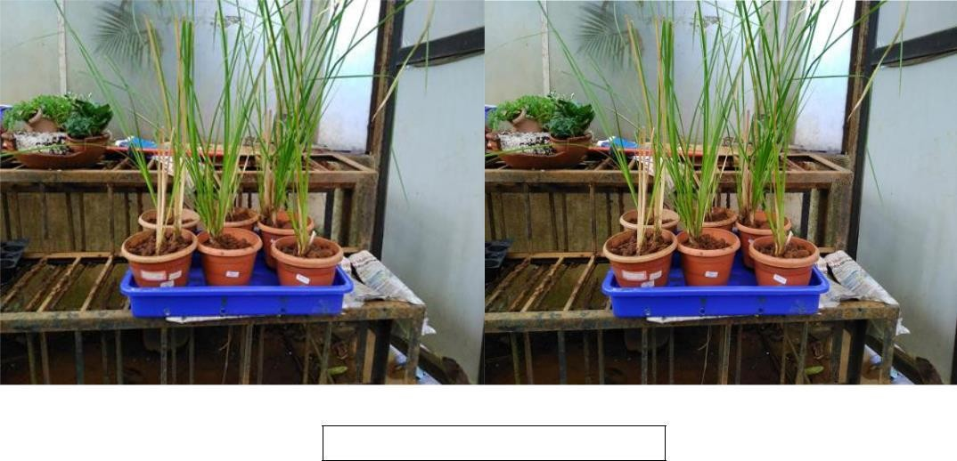

Fig 4.1 Plant in Polyhouse

In the experiment work is the planting of grass in the soil

The experiment consisted of 30 pots of the same size; 6 plants were used as Initial and were grown in pure soil (control).

Remaining 24 pots are kept for final experiments.

All plants were grown in the condition for 15 days and others plants were kept for a 20 days after giving heavy metals doses.

## CHEMICAL USED AND STOCK PREPARATION OF HEAVY METALS:

Three different concentration of heavy metals were given to Vetiver plant, they are: cr, cu, cd

## PREPARATION OF CHROMIUM (CR) STOCK SOLUTION:-

Dissolve 1.923 CrO3 weighted accurately to at least four significant figure in DDW, after complete dissolution acidity with 10 ml HNO3 and dilute to 1 liter with DDW

### CONCENTRATION RANGE

For 50 ppm= 5 ml of cr stock in 100 ml of volumetric flask and dilute it to 100ml For 100ppm = 10 ml of cr stock in 100 ml volumetric flask and dilute it to 100 ml For 200 ppm = 20 ml of cr stock in 100 ml volumetric flask and dilute it to 100 ml

## PREPARATION OF COPPER (CU) STOCK SOLUTION:-

1.252 g of Zinc oxide is dissolved in minimum amount of (1:1) HNo3; add 10ml concentrated HNo3 and dilute to 1litre with H2O.

### CONCENTRATION RANGE

For 50ppm =5 ml of cu stock in 100ml volumetric flask and dilute it to 100 ml For 75ppm = 7.5 ml of cu stock in 100 ml volumetric flask and dilute it to 100 ml Fot 200ppm =20ml of cu stock in 100ml volumetric flask and dilute it to 100 ml

## PREPARATION OF CADMIUM (CD) STALK SOLUTION:-

Dissolve 1.142g Cd weighted accurately to at least 4 significant figure in amount of (1:1) HNO3 and dilute to 1litre with DDW (1ml = 0.1 mg cd)

### CONCENTRATION RANGE

For 10ppm =0.1 ml of cd stock in 100 ml volumetric flask and dilute it to 100 ml For 15 ppm =1.5ml of cd stock in 100 ml volumetric flask and dilute it to 100 ml For 20 ppm =2 ml of cd stock in 100 ml volumetric flask and dilute it to 100 ml

## EXPERIMENTAL PROCEDURE:

Three different concentrations of heavy metals (ppm) used for the experiment.

|  |  |  |  |
| --- | --- | --- | --- |
| Heavy metal | Concentration of heavy metals (ppm) | | |
| I | II | III |
| Cr | 50 | 100 | 200 |
| Cu | 50 | 75 | 100 |
| Cd | 10 | 15 | 20 |

25 ml of each of the concentration were added to 10 Vetiver plants and it was taken care that the solution will not leak out of the pots. Every day the plants were watered with the same amount of water

i.e. 25 ml. This procedure was carried out for 20 days.

## HARVEST AND SAMPLE COLLECTION:

Vetiver plants were harvested, both the control and the plants that were given heavy metals does for 20 days. The shoots were dries for a week and then grinded. Further analysis pf the effects on the biological component was determine the using various techniques and methods.

## MATERIALS:

### SAMPLE PREPARATION:

0.5 g of powered shoot were taken both control and sample. In centrifuge tubes and 2 ml 80% alcohol was added to it after which the volume was made up to 10 ml with distilled water and then centrifuged at 300 rpm for 10 minutes.

### PREPARATION FOR ANTHRONE METHOD:

**Anthrone reagent** was prepared by dissolving 0.2g of Anthrone in 100 ml of ice cooled concentrated sulphuric acid

**Standard** was prepared by dissolving 0.1Dextrose in 1 litter i.e 100 ug/ml glucose. Range was made in the manner of 20, 40, 60, 80, and 100 ug/ml. Absorbance was determined at wavelength 620nm.

### PREPARATION FOR LOWRYS'S METHOD:

**Reagent A** (2%Na2Co3) = 2g Na2CO3 in about 80 ml 0.1N NaOH and make upto 100 ml 0.1 NaOH was prepared by adding 4g of NaOH in 1000ml.

**Reagent B** (2% Na/ K tartrate) = 2g of Na /K tartrate nad dissolve in 80 ml of H2O and then make up to 100 ml.

**Reagent C** (1% cupric sulphate) = 1 g CuSO4. 5H2) in 80 ml H2O and make volume up to 100ml

**Lowrys's reagent** is [Alkaline Copper reagent (freshly prepared)] =Take 100ml of Reagent A in beaker, add 1 ml Reagent B drop by drop and continuous mixing. Add 1 ml of Reagent C drop by drop.

**Standard** was prepared by dissolving 100mg of BSA in 100ml of distilled water in volumetric flask i.e 100 ug/ml. Absorbance was determined at wavelength 660nm.

## ANALYSIS OF THE BIOLOGICAL COMPONENT:

Keep in boiling water bath 10 minutes and observed at 620nm.

### CARBOHYDRATE ESTIMATION

The carbohydrates estimation was done using Anthrone method. Anthrone test is also another general test for all carbohydrates. In this test also, carbohydrates gets dehydrated when react with conc. H2SO4 to form furfural. This furfural reacts with Anthrone to give bluish green colour complex

### PROCEDURE:

|  |  |  |  |
| --- | --- | --- | --- |
| **GLUCOSE** | **STOCK(ML)** | **DILUENT** | **ANTHRONE** |
| **CONCENTRATIO** |  | **(ML)** | **REAGENT(ML)** |
| **N(PPM)** |  |  |  |
| Blank | 0.0 | 1.0 | 4 |
| 20 | 0.2 | 0.8 |  |
| 40 | 0.4 | 0.6 |
| 60 | 0.6 | 0.4 |
| 80 | 0.8 | 0.2 |
| 100 | 1.0 | 0.0 |
| Initial Sample | 0.2 | 0.8 |
| Cu(2.5) (s1) |  |  |
| Cu(3.75) (s2) |
| Cr(2.5) (s3) |
| Cr(7.5) (s4) |
| Cd(7.5) (s5) |

**4.6.2 PROTEIN ESTIMATION**

The principle behind the Lowry method of determining protein concentrations lies in the phenolic group of tyrosine and tryptophan residues (amino acid) in protein will produce a blue purple color complex with maximum absorption in the region of 660nm wavelength with Folin - Ciocalteau reagents which consists of sodium tungstate molybdate and phosphate. Thus the intensity of colour depends on the amount of these aromatic amino acids present and will thus vary for different protein. Most protein estimation techniques use Brovine serum Albumin (BSA) Universally as a standard protein because of its low cost, high purity and ready availability. The Lowry method is sensitive to pH changes and therefore the pH of assay solution should be maintained at 10-10.5.

### PROCEDURE

|  |  |  |  |  |  |  |
| --- | --- | --- | --- | --- | --- | --- |
| **BSA** | **BSA(ML** | **DILUEN** | **LOWRY’S** | **WAIT FOR 10 MIN.** | **FOLIN-** | **INCUBATE AT ROOM TEMP FOR 30 MIN** |
| **CONCENTRATION(PPM** | **)** | **T (ML)** | **REAGENT(ML** | **CIOCALTEA** |
| **)** |  |  | **)** | **REAGENT(ML** |
|  |  |  |  | **)** |
| Blank | 0.0 | 5.0 | 2 | 0.2 |
| 20 | 1.0 | 4.0 |  |  |
| 40 | 2.0 | 3.0 |
| 60 | 3.0 | 2.0 |
| 80 | 4.0 | 1.0 |
| 100 | 5.0 | 0.0 |
| Initial Sample | 0.2 | 4.8 |
| Cu(2.5) (s1) |  |  |
| Cu(3.75) (s2) |
| Cr(2.5) (s3) |
| Cr(7.5) (s4) |
| Cd(7.5) (s5) |

**CHAPTER 5 OBSERVATION**

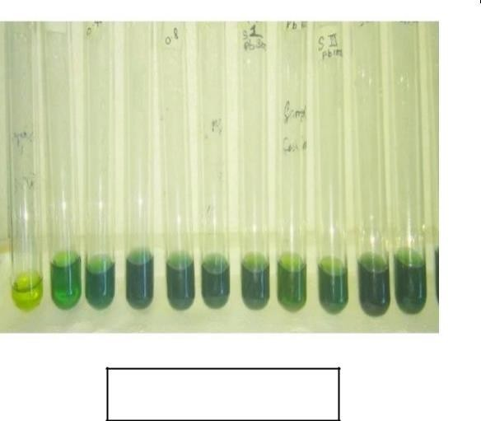

**Fig. 5.1 Anthorne method observation**

1. **ESTIMATION OF CARBOHYDRATE BY ANTHRONE METHOD**

|  |  |
| --- | --- |
| **CONCENTRATION OF GLUCOSE (µg/Ml)** | **Absorbance (O.D.At 620nm)** |
| Blank | 0 |
| 0.2 | 0.125 |
| 0.4 | 0.304 |
| 0.6 | 0.505 |
| 0.8 | 0.701 |
| 1 | 0.870 |
| Initial Sample | 0.197 |
| S1 (2.5 does of copper ) | 0.126 |
| S2 (3.75 does of copper ) | 0.044 |
| S3 (2.5 does of chromium ) | 0.138 |
| S4 (7.5 does of chromium ) | 0.071 |
| S5 (2.5 does of cadmium ) | 0.078 |

1. **ESTIMATION OF PROTEIN BY LOWRY’S METHOD LEAF**

|  |  |
| --- | --- |
| **Concentration Of BSA (µg/Ml)** | **Absorbance (O.D. At 660 nm)** |
| Blank | 0 |
| 0.2 | 0.054 |
| 0.4 | 0.278 |
| 0.6 | 0.471 |
| 0.8 | 0.464 |
| 1 | 0.627 |
| Initial Sample | 0.151 |
| S1 (2.5 does of copper ) | 0.126 |
| S2 (3.75 does of copper ) | 0.044 |
| S3 (2.5 does of chromium ) | 0.138 |
| S4 (7.5 does of chromium ) | 0.071 |
| S5 (2.5 does of cadmium ) | 0.078 |

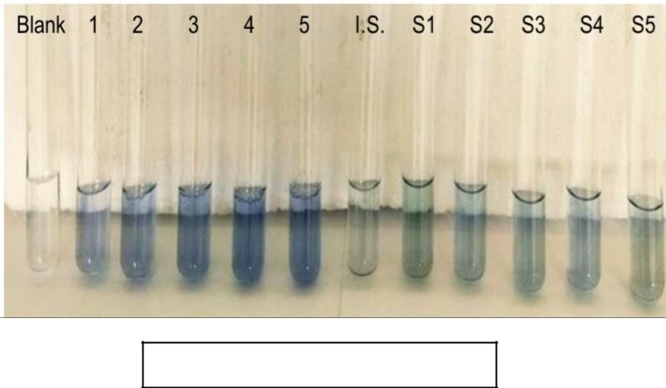

**Fig. 5.2 Lowry’s method observation**

**CHAPTER 6 RESULT AND DISCUSSION**

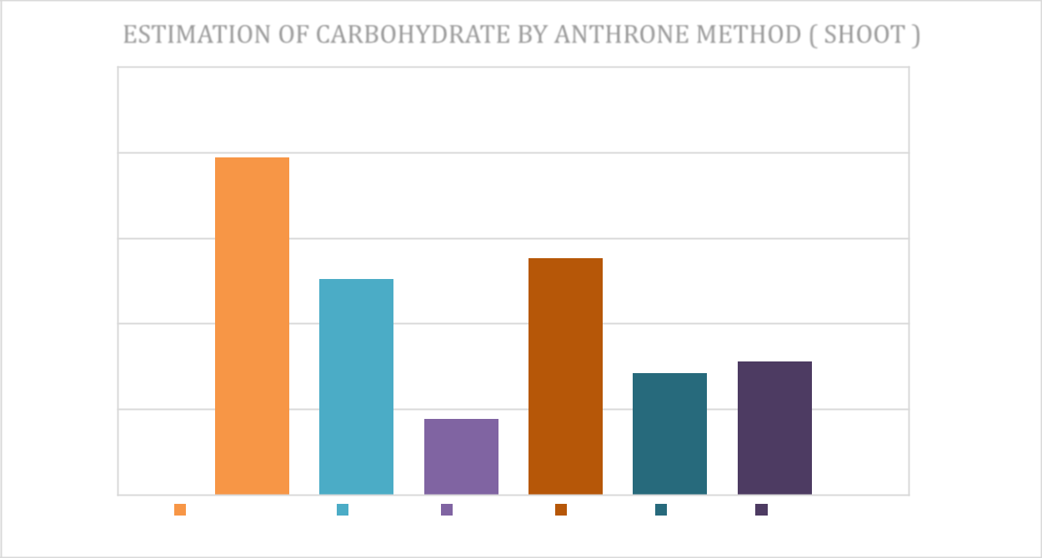

ESTIMATION OF CARBOHYDRATE BY ANTHRONE METHOD (

**Concentation of Glucose in**

**Estimation of Carbohydrate by Anthrone Method (Shoot)**

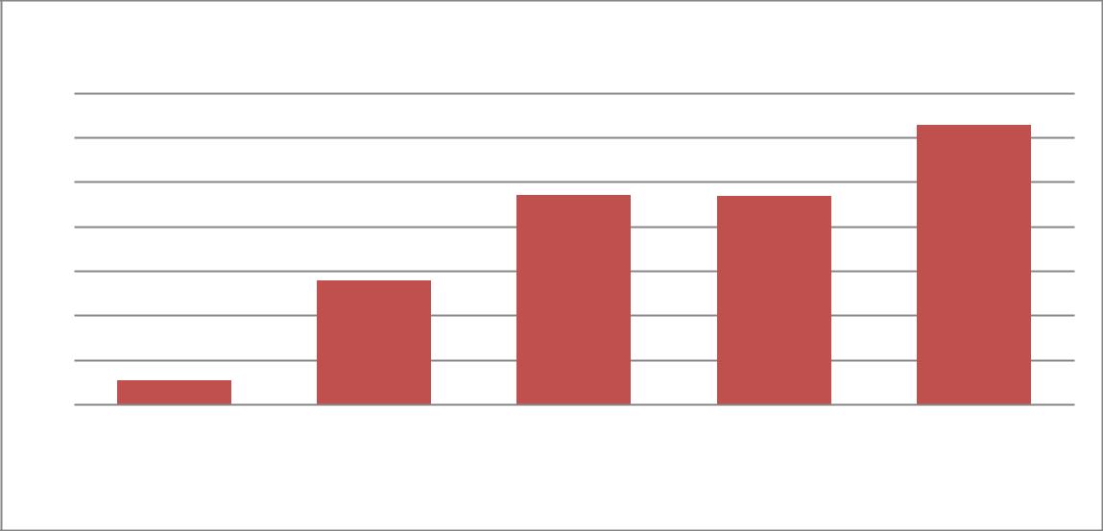

**Standard**

0.

7

0.

6

0.

5

0.

4

0.

3

0.

0.

0.

0.

1

Standard

|  |  |  |  |  |  |  |
| --- | --- | --- | --- | --- | --- | --- |
|  | 0.25 |  |  |  |  |  |
|  | 0.2 |  |  |  |  |  |
| **nm )** | 0.15 |  |  |  |  |  |
| **at** |  |  |  |  |  |  |
| **(O.** | 0.1 |  |  |  |  |  |
| **Absorban** | 0.05 |  |  |  |  |  |
| 0 |  |  |  |  |  |
|  | Initial Sample | Cu 2.5 | Cu 3.75 | Cr 2.5 | Cr 7.5 | Cd 7.5 |

**Estimation of Protein by Lowry's Method (Shoot)**

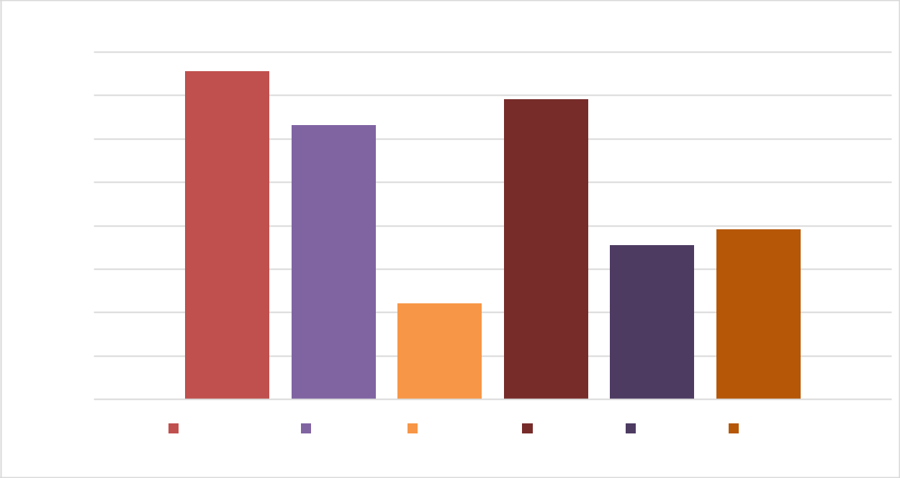

ESTIMATION OF PROTEIN BY LOWRY'S METHOD

**Concentration of glucose in**

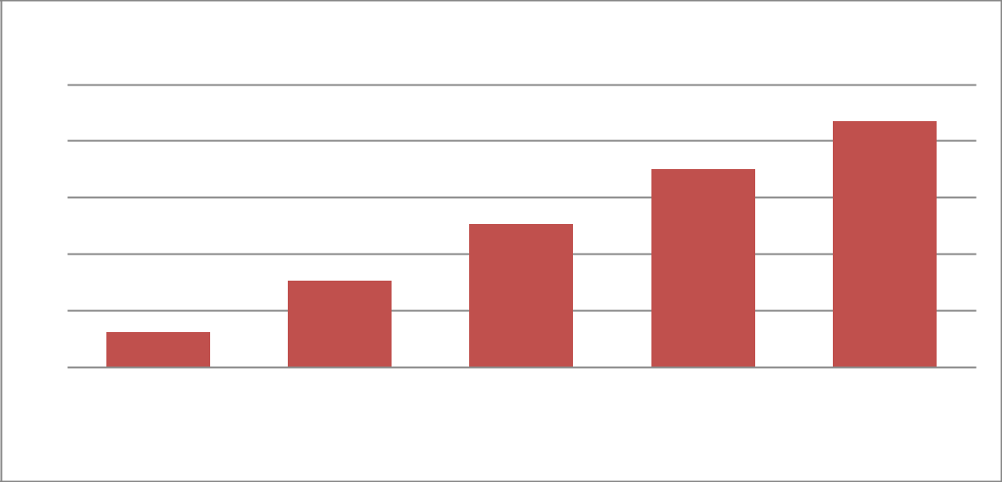

**Standard**

1

0.8

0.6

0.4

0.2

0

0.

2

0.4

0.

1

Standard

|  |  |  |  |  |  |  |
| --- | --- | --- | --- | --- | --- | --- |
|  | 0.16 |  |  |  |  |  |
|  | 0.14 |  |  |  |  |  |
|  | 0.12 |  |  |  |  |  |
| **nm** | 0.1 |  |  |  |  |  |
| **62** |  |  |  |  |  |  |
|  | 0.08 |  |  |  |  |  |
| **O.D** | 0.06 |  |  |  |  |  |
| **(** |  |  |  |  |  |  |
| **Absorban** | 0.04 |  |  |  |  |  |
| 0.02 |  |  |  |  |  |
|  | 0 |  |  |  |  |  |
|  | Initial Sample | S1. Cu 2.5 | S2. Cu 3.75 | S3. Cr 2.5 | S4. Cr 7.5 | S5. Cd 7.5 |

**CHAPTER 7 CONCLUSION**

1. The vetiver plant was grown and after 20 days leaves of the plant were dried over a period of a 20 day and the dried leaves were used as initial samples for testing of verious components. Again for one week 5 plants were given different concentration (2.5, 3.75) of copper, (2.5, 7.5) of chromium (7.5) of cadmium. There leaves were dried for a week and tested for the same component as the previous untreated sample of leaves and compared.
2. The carbohydrates estimation was done using Anthrone method, different in the concentration of carbohydrates of the initial, untreated plants, leaves and the plants leaves treated with heavy metals were seen. The initial samples (untreated) showed higher concentration of carbohydrates whereas, the one treated with heavy metals had lower levels of carbohydrates.
3. The protein estimation was done using Lowry's method, differences in the concentrations of protein of the initial samples ( untreated) showed higher concentration of protein whereas the one treated with heavy metals had lower levels of protein
4. There were differences in the concentration of the different components due to the difference in the concentration (2.5, 3.75, 7.5) of heavy metals ( copper, chromium, cadmium) they were given.
5. The spectrometer analysis showed that the samples contained various others functional groups like alkene, amino, etc in it the most common contaminants found was C - C aromatic group in all the heavy metals treated samples all these functional groups are possible contaminants in the samples, to determine their amount further testing needs to be done.

# CHAPTER 8 REFERENCES

* + Abdul ghai et al.,(2006) Toxic effects of heavy metals on plant growth and metal accumulation in maize.
  + Anil kumar, Sagarika Garg v. et. at., (2008) Biochemical Test : Principles and Protocols 87-89
  + B. Sc. Third year Microbiology journal
  + Bijoy Krishna Roy, Rajendra Prasad and Gunjan Z.,et al., (2005)Heavy metals accumulation and changes in metabolic parameters 152-168.
  + Dursun Kisa (bartin University) Mahfuz Elmastas (University of Health Science, Istanbul Turkey), Lokman (Ege University), Omer Kayir (Hitit University) Response of the phenolic compound of zea mays under heavy metals stress October 2016.
  + Hartree E. E. (1972). Anal. Biochem. 48:422 (This modification makes the assay linear over alarger range than the original assay) BL 301-2
  + Heavy metal polluted soils : effect on plants and bioremediation methods ( published 12 agust 2014)
  + Karabi Das, Parth Pratin Kalita, Manash Pratim sarma, Nayan Talukdar, parimira Kakoti; Extraction, estimation and comprision of proteins and carbohydrates from different part of Costus specious and a brief study on its phyto chemical content .
  + Lowery, O. H., Rosebrough, N. J., Farr, A. L., and Randall, R. J. (1951). Biol. Chem193:265 (The original method)
  + S. K. Sawhney and Randhir singh et at., (2008) ntroductory practical Biochemistry.
  + Textbook of biochemistry.
  + Wilson k. And Walker, J (2000) paractical Biochemistry : Principles and Techniques Cambridge University press.